Early Humans Study Guide

Thousands of years before civilizations developed writing, people lived with no permanent homes. They were called nomads. They hunted and fished for food. They also gathered plants that could be eaten later. Nomads moved from one location to another. They needed to move when plants or animals were scarce. Their survival depended on finding these necessities every day.
- According to this passage, nomads are people who:

- According to this passage, early people are nomads because they:

- The Paleolithic era refers to a time when early humans did what? List three activities early humans performed.

- The making of tools and weapons to hunt and work with in the Stone Age is an example of which theme of social studies?

- The ability to make fire was important for many reasons such as cooking food. What were the benefits of cooking food?

- What is the term used to describe the process by which species (of plant or animal) changes over time to adapt to their environment through natural selection?

- Describe the lives of people in hunting and gathering societies?

- From what continent did early humans migrate?

- What part of the world did humans reach last?

- Explain what led to the beginning of more defined social classes, as the Neolithic Age began?

- Explain the Neolithic Revolution?

- The Neolithic era began with what development?

- What was the greatest benefit when people began farming?

- Why did people live in larger communities in the Neolithic era than in earlier times?

- If you were a Neolithic trader, what most likely happened as you traveled and traded?

- When Neolithic farming communities divided jobs among different people, they were able to develop:

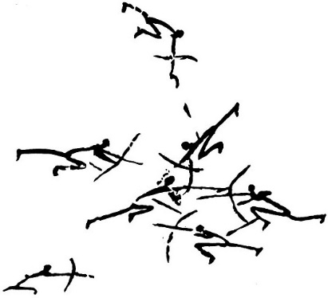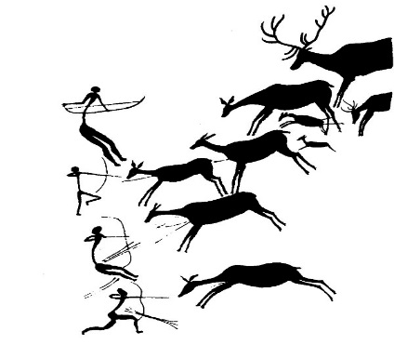

- Which can be concluded about people of the Neolithic period from these paintings?

- Hunters and gatherers who roamed in search of food became more sophisticated. Evidence of this sophistication is their cave drawings. The cave drawings found in France, Spain, and areas of Africa were probably done for all of the following reasons. List three.

