Early Humans Study Guide

Thousands of years before civilizations developed writing, people lived with no permanent homes. They were called nomads. They hunted and fished for food. They also gathered plants that could be eaten later. Nomads moved from one location to another. They needed to move when plants or animals were scarce. Their survival depended on finding these necessities every day.
- According to this passage, nomads are people who:
People who do not have permeant homes. People who move from place to place

- According to this passage, early people are nomads because they:
Needed to move in order to find food sources
- The Paleolithic era refers to a time when early humans did what? List three activities early humans performed.
Used Stone tools, were nomadic, hunted and gathered, made cave paintings, used fire to cook their food, lived in caves and/or animal skin tents.
- The making of tools and weapons to hunt and work with in the Stone Age is an example of which theme of social studies?
Economics/Finance

- The ability to make fire was important for many reasons such as cooking food. What were the benefits of cooking food?
Made it easier to chew and killed diseases.

- What is the term used to describe the process by which species (of plant or animal) changes over time to adapt to their environment through natural selection?
Evolution
- Describe the lives of people in hunting and gathering societies?
People spent all of their time producing food

- From what continent did early humans migrate?
Africa
- What part of the world did humans reach last?
South America
- Explain what led to the beginning of more defined social classes, as the Neolithic Age began?
The growth of communities
- Explain the Neolithic Revolution?
People began to settle in small communities and practice agriculture

- The Neolithic era began with what development?
Farming (Agriculture)

- What was the greatest benefit when people began farming?
They had a larger and more stable supply of food
- Why did people live in larger communities in the Neolithic era than in earlier times?
They could grow more food to feed more people

- If you were a Neolithic trader, what most likely happened as you traveled and traded?
You discovered new ideas and technologies

- When Neolithic farming communities divided jobs among different people, they were able to develop:
Specialized Skills

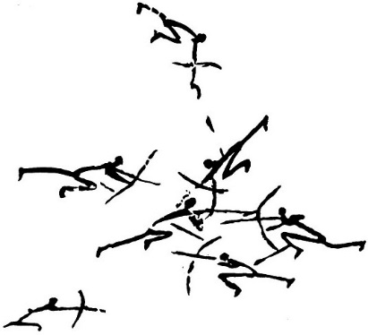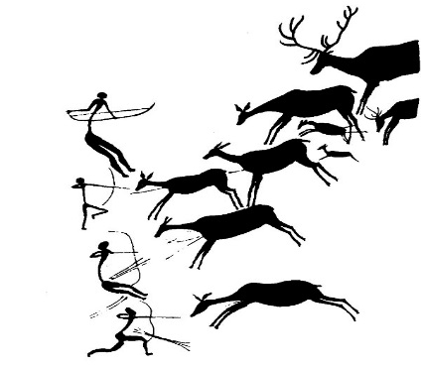

- Which can be concluded about people of the Neolithic period from these paintings?

Neolithic people hunted and fought in wars
- Hunters and gatherers who roamed in search of food became more sophisticated. Evidence of this sophistication is their cave drawings. The cave drawings found in France, Spain, and areas of Africa were probably done for all of the following reasons. List three.
Educating younger hunters, a part of an early religion, a method of entertainment, listing historical achievement(s)

