River valley study guide

This timeline shows the approximate years in which various ancient kingdoms began.
B.C.
<3000 2500 2000 1500 1000 500

Mesopotamian city-states Shang dynasty Roman republic
begin in present day Iraq begins in present begins in present
day China day Italy
Mycenaean Empire
begins in present
day Greece
1. The Indus civilization in India lasted from 2500 to 1700 B.C. Which is older than the Indus civilization?
Mesopotamia
2. Gilgamesh is an ancient tale written on clay tablets that tells about the life of an important king who ruled around 2500 B.C. Based on the timeline, which did Gilgamesh rule?
Mesopotamia

3. Which was the main advantage of cuneiform script in Mesopotamian social structure?
it supported a system for keeping business records

4. Why did farming lead to permanent villages?
people needed to stay and tend their crops
5. Which feature of geography was the most important in the development of early river valley civilizations?
Fertile soil from rivers

6. How did calendars contribute to growth in cities and agriculture in ancient Mesopotamia?
They helped farmers plan their crops to avoid floods, which allowed them to grow more food and to feed more people in the cities

7. Which is the best explanation for why Mesopotamians built canals?
They needed a way to control the river’s flow to prevent flooding and increase farming

8. How did the metal plow help Mesopotamian trade with other civilizations?
Created a surplus of food which lead to an increase in trading
9. Which of the following facts serves as evidence that the Mesopotamians were polytheistic?
a. Mesopotamian government was centered on the city-state
b. Goods made in India and Egypt were brought to Mesopotamia by traders
c. The Sumerian story of the Great Flood is similar to the Bible story about Noah’s Ark
d. The city of Ur had temples dedicated to worshipping the goddess Ishtar and the god Enki
10. Who was the ancient Babylonian king who created the earliest known code of laws which focused on harsh punishments to keep order in society?

11. High crop yields in ancient Mesopotamia contributed most directly to the development of what?
Division of labor

Writing
Some of the first writing was developed in Mesopotamia. Many social scientists credit the Sumerian people for this writing. The writing looked like symbols and was called cuneiform. The Sumerians wrote on clay tablets. Later, the Phoenicians, while still using cuneiform, began to produce their own 22-letter alphabet. This development made it easier for people of the ancient world to learn to read and write. In some ways, their alphabet looked like Egyptian hieroglyphics. The Greeks and Romans adapted the Phoenician writing form to create their own alphabet.
Writing was used in commerce. It was especially important communicating the history of people. It was a powerful way of letting people know the laws. The first written set of laws was called the Code of Hammurabi.

14. The reading above discusses that writing was used in commerce. In this passage, what does the word commerce refer to?
Trading and/or business
15. What was a result of the development of an alphabet in ancient times, according to the passage above?
Made it easier for people to read and write

Egyptian Innovation and Trading
Technological and cultural advances meant Egyptians had a high standard of living. Egyptians could sell or trade their innovations to other societies, which made Egypt a powerful and influential nation. Many societies adopted and adapted the culture and technological innovations of Egypt.
Trading meant that Egyptian innovations and technology were used around the world. People in other countries were able to improve their lives. They adapted the Egyptian products to fit their needs. They added to the knowledge they learned from the Egyptians and invented new technology. Those new innovations traveled to even more places and changed even more lives. Some of their innovations are still used today.
16. According to the passage above, what is one reason Egypt was able to become powerful?
They could sell or trade their innovations to other societies
17. According to the passage, how did trading with Egypt positively affect other civilizations?

By trading their new technology they improved the lives of the people they traded with.

19. Which statement shows how trade routes influenced ancient societies?
a. As travel over land became easier, trade by water became unnecessary
b. As different civilizations traded goods, they also shared cultural values and beliefs
c. As trade developed, long-distance travel became safe and easy for each civilization
d. As silk grew popular, it became a common material used in clothing across civilizations

21. Why did some ancient civilizations write and publish their laws?
So that people knew their rights and responsibilities
24. As migration occurs, aspects of people’s lifestyles blend together. This is an example of what?
Cultural Diffusion
25. How did the invasion of the Aryans change the Indus River Valley?
They brought Hinduism and the Caste System

26. ‘The number system developed by the Gupta mathematicians spread around the world largely as a result of Middle Eastern traders’
Which factor contributed most to the spread of the mathematical system developed in India during the Gupta Empire?
Middle Eastern Traders

27. What were the two major cities that developed in the Indus River Valley?
Harappa and Mohenjo Daro

28. Which statement best explains how the monsoons affected the development of early Indian civilizations?
a. The flooding caused by monsoons slowed the growth of the population in early Indian civilizations.
b. the water brought by monsoon rains allowed agriculture to develop away from India’s major rivers.
c. the wetness from the monsoons pushed many to migrate farther south in search of a better climate.
d. the harsh winters caused by strong monsoon winds blowing in from Central Asia made life more difficult.
29.How did Hinduism develop as a religion?

31. Which statement best explains this feature of the caste system?
‘The Indian caste system places warriors and soldiers at a higher level than merchants and farmers.’
a. the priests who occupy the highest caste are first trained as soldiers.
b. security was a concern in ancient India because of its vulnerability to invasion.
c. there were fewer merchants and farmers in ancient India than warriors and soldiers.
d. Hinduism states that warriors be subject to the will of merchants and farmers

The Caste System
The caste system developed during the Gupta period in India, about 400 AD. Castes created social and political order. People could not rise to another caste or change caste by marriage. A person could fall to a lower caste by behaving badly. The rules of the caste system covered marriage, jobs and social habits, such as the way someone ate or drank. There was little need to have powerful local leaders because the strict rules of the caste system kept order.
32. What did the caste system create?
a. a set of rules for the Brahmin c. fairness and equality for all people
b. social and political order d. chaos and disorder

34. Which factor restricted trade between China and civilizations to its west and southwest?
Significant geographic obstacles
35. Which statement best demonstrates how the structure of the government in ancient China was similar to the structure of the traditional Chinese family?
The people obeyed and respected the emperor like children obeyed their parents
36. The concept of the “Mandate of Heaven” was used to justify
The rule of the emperor
37. Which events led most to the construction of the Great Wall during the Qin dynasty?
Nomadic Invasions

39. Which statement explains why the development of the Silk Road benefited the Chinese economy?
Chinese civilization first developed in a fertile river valley
40 .Which factor contributed most to the spread of Buddhism from India to China?

trade connections
The Silk Road
The Silk Road connected China with far-off lands. It was the first major trade system of its kind. Trade became a major part of the early Chinese economy. The Silk Road was a series of trade routes that connected China with markets in Europe, Central Asia, South Asia, North Africa, and the Middle East.
The Silk Road was not a continuous road but rather a series of trade routes that connected China with Europe, India, the Middle East, and northern Africa. One of the main routes to the West extended about 4,000 miles. The sea routes of the Silk Road traveled via the South China Sea and the Indian Ocean to Iraq or Egypt. On the other side, merchants brought the goods to Alexandria, Egypt, and other places Europeans used for trade.
41. According to the passage, what was the Silk Road?
Silk Road was a series of trade routes that connected China with markets in Europe, Central Asia, South Asia, North Africa, and the Middle East.

42. According to the passage, what were two water ways used for trading along the sea routes of the Silk Road?
South China Sea and the Indian Ocean
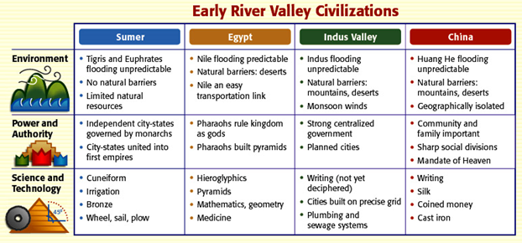
43. Due to its geography, which civilization would be most likely invaded?
Sumer
44. Which Civilization had city states?
Sumer
45. Which civilization had cities with plumbing that were planned on a precise grid

Indus Valley
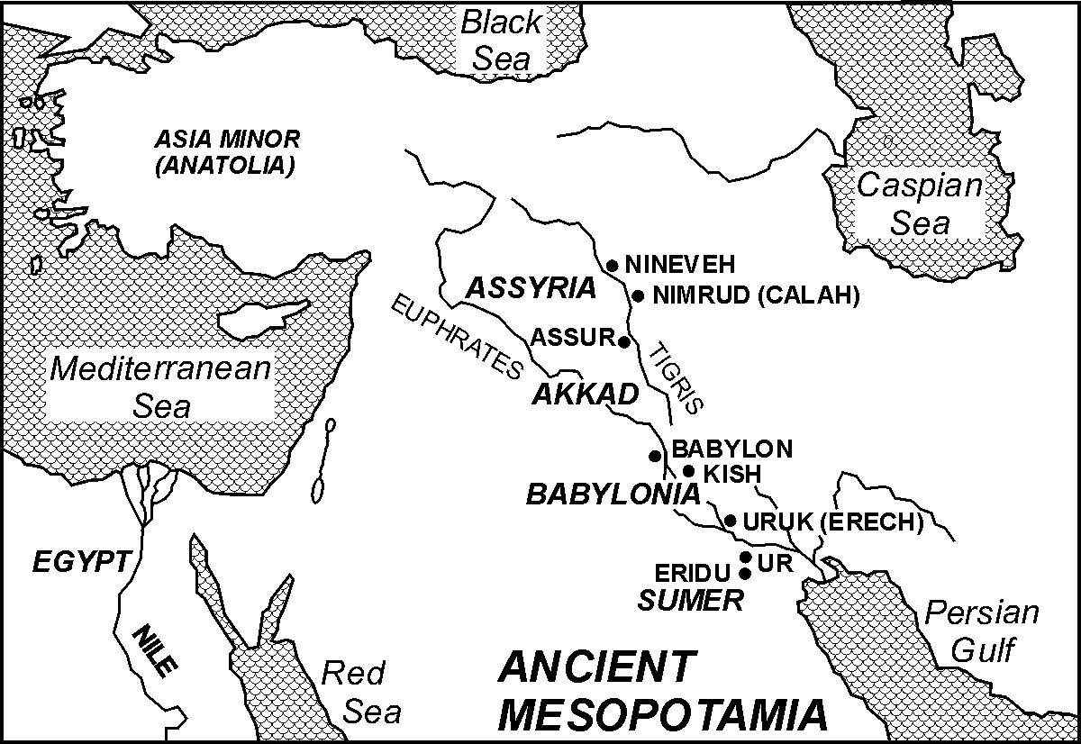
46. Based on this map which body of water did Ancient Mesopotamia and Ancient Egypt share?
Mediterranean Sea

47. . Which river was Babylon located on ?
Euphrates
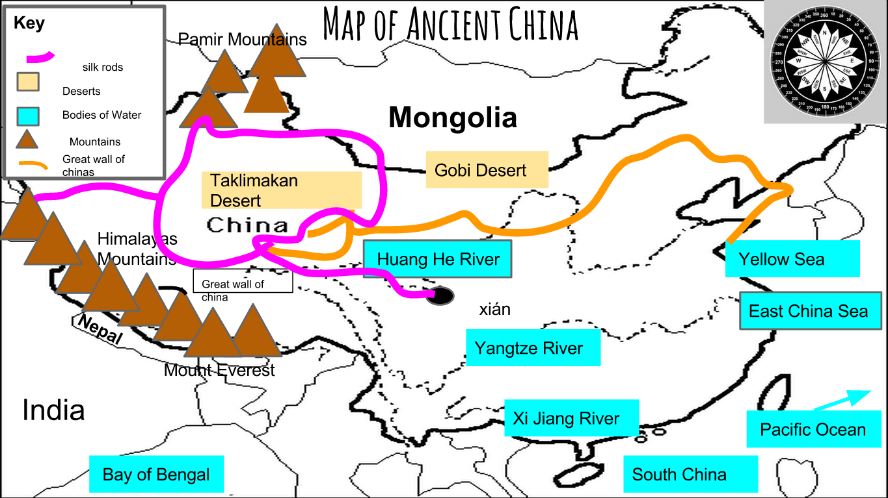
48. Name two physical features that the Silk Road ran through
Taklimakan Desert, Himalayan Mountains
49. Which river did the Great Wall of China intersect?
Huang He
50. Are you going to study this study guide and make an “A” on this test?

